 

INSTITUTE FOR ADVANCED COMPUTING AND SOFTWARE DEVELOPMENT AKURDI, PUNE

Documentation On

**“e-COMMERCE BASED ART GALLERY”**

PG-DAC SEP 2022

*Submitted By:*

**Group No: 106**

# Pooja V. Sadkar (229076)

# Dakshayanee S. Yerule (229145)

**Mr. Rohit Puranik Mr. Narendra Pawar**

**Centre Coordinator Project Guide**

# Table of Contents

1. Introduction 3

Problem Statement 3

Aim & Objectives 3

1. Overall Description 4

Proposed Methodology 4

Operating Environment 4

Design and Implementation Constraints 5

1. Requirements Specification 6

External Interface Requirements 6

1. System Diagram 7

Activity Diagram 7

Data Flow Diagram 10

Class Diagram 12

Use Case Diagram 13

ER Diagram 15

1. Table Structure 17

Course 17

Subject 17

Admin Student 17

Student 17

Admin Faculty 18

Faculty 18

Assignments 18

Notes 19

Classroom 19

Daily Schedule 19

Placements 19

Announcement 20

Contact Number 20

User 20

1. Conclusion 21

Future Scope 21

1. References 22

**List of Figures**

Figure 1 Admin Activity Diagram 7

Figure 2 Student Activity Diagram 8

Figure 3 Faculty Activity Diagram 9

Figure 4 Level 0 Data Flow Diagram 10

Figure 5 Level 1 Data Flow Diagram 10

Figure 6 Level 2 Data Flow Diagram for Admin 10

Figure 7 Level 2 Data Flow Diagram Course 11

Figure 8 Class Diagram 12

Figure 9 Use Case Diagram for Student 13

Figure 10 Use Case Diagram for Faculty 13

Figure 11 Use Case Diagram for Admin 14

Figure 12 ER (MySQL Auto Generated) 15

Figure 13 ER Diagram 16

**Introduction:**

# INTRODUCTION.

This is e-commerce based art gallery where artists can showcase and sell their artworks online, and customers can easily browse and purchase the artworks they like. The website will be designed to provide a user-friendly experience for both artists and customers, with easy navigation and streamlined checkout processes.

## Problem Statement:

There will be three types of roles in the website, the first one is Customer who can search and discover the art without any need to register or login but if they want to buy any art they have to register and login. Second one is a Artist who has to register and login to post their art works for display and selling on the website and third user is admin who specifies authority and restrictions on the Website. There will be a separate console for Artist, Customer and Admin.

## Aims and Objective:

Online Art Gallery is a platform for e-commerce that brings artists and artists from around the world into the network. This web-site shows a wide array of paintings, drawings, prints, digital art, sculpture and photography and offers artists a curated atmosphere in which their work can be displayed and sold.

In other words, our college portal has, following objectives:

1. Artist Profiles: Artists will have the ability to create their own profiles, where they can upload their artworks, provide descriptions, and set prices. They will also be able to manage their inventory and sales.
2. Artwork Catalogue: The website will have a searchable catalogue of artworks, organized by category, medium, style, and price. Customers will be able to filter and sort the artworks to find what they are looking for.
3. Shopping Cart and Checkout: Customers will be able to add artworks to their shopping cart and proceed to checkout, where they can review their order, enter shipping and payment information, and complete the transaction securely.
4. Payment Gateway Integration: The website will integrate with a secure payment gateway, such as Stripe or PayPal, to process customer payments and ensure the security of sensitive information.
5. Order Management: The website will provide a dashboard for artists to manage their orders, including tracking and shipping information, and customer communication.
6. Reviews and Ratings: Customers will be able to leave reviews and ratings for the artworks they purchase, which will help other customers make informed decisions and help artists improve their offerings.
7. Social Media Integration: The website will integrate with social media platforms, such as Instagram and Facebook, to allow artists to promote their artworks and reach a wider audience.

.

**Proposed Methodology:**

# OVERALL DESCRIPTION.

There will be three types of users using this website Artist, Customer and Admin, Artist can exhibit and sell their art Customer can buy the art, Admin can manage the Website, manage Artist, User and view reports.

Online Art Gallery is an online e-commerce website which will help connect Artist from around the world with customers. compared to other websites like zatista, Art Finder, Art.com, Online art Gallery offers better services in terms of pricing. It has user friendly navigation bar.

Comparison with other websites login and payment process, with the user being able to make the transaction, ease of navigation, and account setup in comparison with other websites, within a smaller span of time in our project. There are many applications, but the important relationship is ease of use and easy account setup in online art gallery.

## Operating Environment:

Server Side:

**Processor:** Intel® Xeon® processor 3500 series

**HDD:** Minimum 500GB Disk Space

**RAM:** Minimum 4GB **OS:** Windows 10, Linux 6 **Database:** MySQL

Client Side (minimum requirement):

**Processor:** Intel Dual Core

**HDD:** Minimum 80GB Disk Space

**RAM:** Minimum 2GB

**OS:** Windows 7, Linux

## Design and Implementation Constraints:

* The application will use JavaScript, jQuery and CSS as main web technologies.
* HTTP and FTP protocols are used as communication protocols. FTP is used to upload the web application in live domain and the client can access it via HTTP protocol.
* SMTP protocol is used for Email communication.
* Several types of validations make this web application a secured one and SQL Injections can also be prevented.
* Since Student’s Online Portal is a web-based application, internet connection must be established.
* The Student’s Online Portal will be used on PCs and will function via internet or intranet in any web browser.

**External Interface Requirements:**

# Requirements Specification.

User Interfaces:

* + All the users will see the same page when they enter in this website. This page asks the users a username and a password.
  + After being authenticated by correct username and password, user will be redirect to their corresponding profile where they can do various activities.
  + The user interface will be simple and consistence, using terminology commonly understood by intended users of the system. The system will have simple interface, consistence with standard interface, to eliminate need for user training of infrequent users.

Hardware Interfaces:

* + No extra hardware interfaces are needed.
  + The system will use the standard hardware and data communication resources.

This includes, but not limited to, general network connection at the server/hosting site, network server and network management tools.

Application Interfaces:

**Web Browser:**

The system is a web-based application; clients need a modern web browser such as Mozilla Firebox, Internet Explorer, Opera, and Chrome. The computer must have an Internet connection in order to be able to access the system.

Communications Interfaces:

* + This system uses communication resources which includes but not limited to, HTTP protocol for communication with the web browser and web server and TCP/IP network protocol with HTTP protocol.
  + This application will communicate with the database that holds all the booking information. Users can contact with server side through HTTP protocol by means of a function that is called HTTP Service. This function allows the application to use the data retrieved by server to fulfil the request fired by the user.

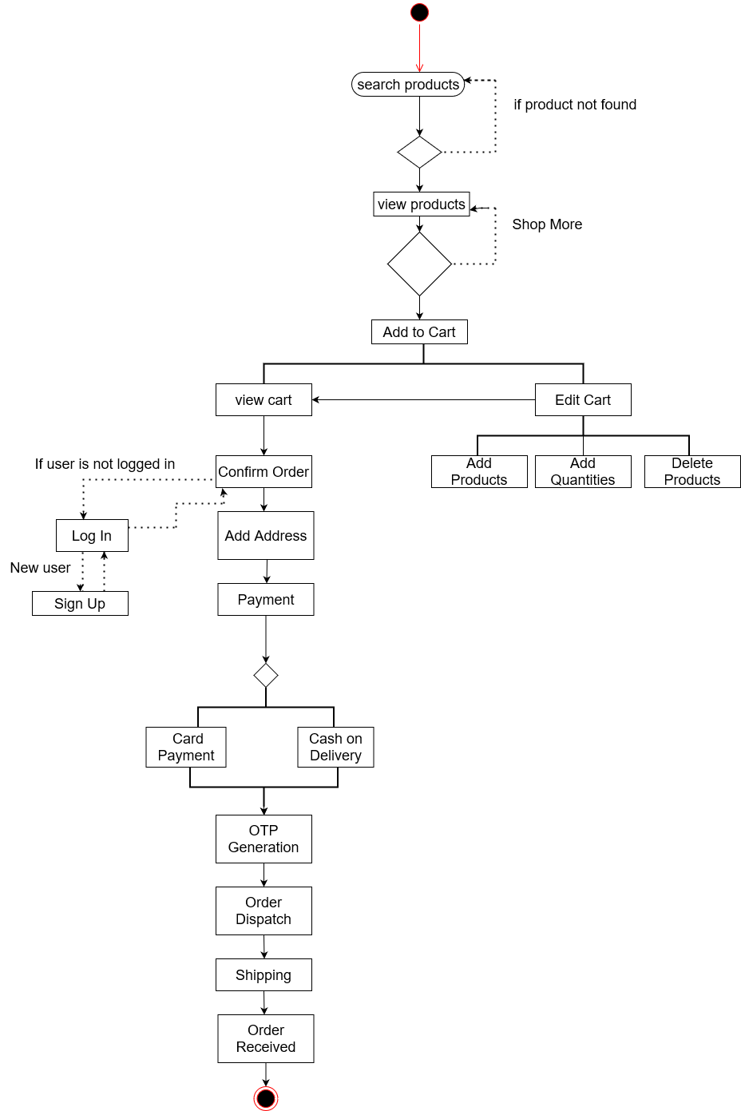

### Information Flow for Artist

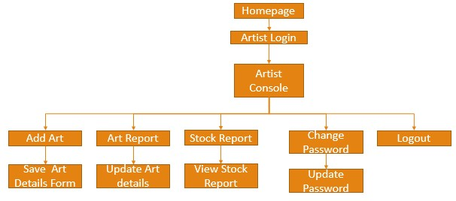

Artist can sell and exhibit the art on the website.

Artist can Upload Pictures of the art and provide description and fix a price for the art.

Artist will have its own console.

Artist can only be added by the administrator.

### Information Flow for Artist